CODS 612 · COMPUTATIONAL OPTIMIZATION IN FINANCE
Final Project · Spring 2026
Optimal Execution
with Power-Law Market Impact
A comparison of the linear Almgren-Chriss baseline
with the empirical power-law (square-root) impact model.
AUTHORS
Ali Almehairbi
Mohamed Alhmoudi
INSTRUCTOR
Professor Yerkin

1. Introduction
Imagine a large fund that owns 1,000,000 shares of a single stock. The fund manager decides to sell all of these shares during one trading day. The manager cannot sell them all at once. If a trader dumps one million shares in a single order, the market price drops sharply. This is called market impact. But selling too slowly is also risky. While the fund is still holding shares, the price can move against it. So the manager faces a tradeoff: sell fast and pay a high impact cost, or sell slowly and take on more risk.
The Almgren-Chriss model from the year 2000 is the classical tool that solves this tradeoff. It finds the best trading schedule that balances impact cost and holding risk. The original model assumes that impact is a linear function of the trading speed, which makes the math simple. But real markets do not behave this way.
Empirical research over the last twenty years shows that market impact follows a power law. When a trader doubles the size of a trade, the cost does not exactly double or quadruple. It grows by a fractional power — usually a square root. This is sometimes called the "Square Root Law" of market impact.
This project has one clear goal. We compare the classical linear model with the more realistic power-law model. We run both models on the same problem with the same parameters. Then we measure how much money is lost when the linear model is used in a world that actually follows the power-law rule. In short, we want to answer the question: how much does it matter if we use the wrong impact model?

1.1 What this report does
- We solve the linear Almgren-Chriss problem using its closed-form formula.
- We solve the power-law problem using numerical optimization.
- We compare the two trajectories and their costs.
- We study how the cost gap grows as the market becomes more non-linear.
- We explain what this means for real execution desks.

2. Theoretical Framework
This section builds the math step by step. We first set up the variables. Then we write the cost function. Then we show the linear and power-law versions side by side.

2.1 Setting up the problem
Let X be the number of shares we start with. Let N be the number of trading periods. In this project, X is one million shares and N is 50 half-hour periods. This matches a full trading day of about 6.5 hours.
We use two main variables:
- x_k = number of shares still held at the end of period k.
- v_k = number of shares sold in period k, which equals x_(k-1) minus x_k.
At the start, we hold all the shares, so x_0 = X. At the end of the day, we must be fully liquidated, so x_N = 0. The sum of all v_k must equal X, meaning we sell exactly our starting inventory across the day.

2.2 The cost function
The manager wants to minimize total cost. In both models, the total cost has two parts: an impact cost and a risk penalty.
General objective function
minimize Σ [ η · |v_k|^(1+β) + γ · σ² · x_k² ]

where η is the impact coefficient, γ is risk aversion,
σ is the daily volatility, and β is the impact exponent.

The first term — η · |v_k|^(1+β) — is the impact cost. It grows when we trade fast. The faster we trade, the larger each v_k, and the more we push prices against ourselves.
The second term — γ · σ² · x_k² — is the risk penalty. It grows when we hold large amounts of shares for a long time. Volatile stocks in risky markets create bigger penalties.
The two terms pull in opposite directions. The first wants us to slow down. The second wants us to speed up. The optimal schedule is the one that balances both forces.

2.3 The linear model
When β = 1.0, the impact term becomes η · v_k². This is quadratic in the trade size. The full problem becomes a Quadratic Program (QP). Because every term is quadratic or linear, classical calculus methods work. Almgren and Chriss showed that the optimal trajectory has a closed-form solution:
Linear model — closed-form solution
x_k = X · sinh( κ · (N − k) ) / sinh( κ · N )

where κ = √( γ · σ² / η ) controls the shape of the curve.
The parameter κ (kappa) is the key. It measures how urgent the liquidation is. When κ is small, the trader is patient and sells evenly — called TWAP, or Time-Weighted Average Price. When κ is large, the trader front-loads the schedule and sells aggressively at the start.

2.4 The power-law model
When β is less than 1.0, the impact function becomes concave. For example, at β = 0.6, the impact term is η · |v_k|^1.6. Doubling the trade size now only multiplies the cost by about 3, not 4. The market punishes large trades less harshly than the linear model assumes.
The fractional exponent creates two problems. First, there is no closed-form solution. We must solve it numerically. Second, raising a negative number to a fractional power is undefined, so we need the absolute value |v_k| to keep the math well-defined during the optimization search.
We solve this problem using scipy.optimize.minimize with the SLSQP (Sequential Least Squares Quadratic Programming) method. The solver treats the N-1 intermediate inventory levels as decision variables. The boundary values x_0 = X and x_N = 0 are fixed.

3. Methodology
This section describes how we built and ran the experiments.

3.1 Parameters
We used exactly the parameters given in the project brief:
Symbol | Value | Meaning
X | 1,000,000 shares | Initial inventory to liquidate
N | 50 periods | Half-hour trading bins (one trading day)
σ | 0.02 | Daily price volatility ($2 on a $100 stock)
γ | 2.5 × 10⁻⁶ | Risk aversion coefficient
η | 2.0 × 10⁻⁴ | Temporary impact coefficient
β (linear) | 1.0 | Exponent for the classical baseline
β (power-law) | 0.6 | Empirical exponent from the Square Root Law

3.2 Implementation
We built the project in Python using NumPy, SciPy, and Matplotlib. The work was split between two members:
Ali implemented the linear baseline using the closed-form sinh formula.
Mohamed implemented the power-law extension using scipy.optimize.minimize with SLSQP.
Both modules share a single set_params() function, so the two models always use identical inputs. We also wrote a comparison script that imports both solvers, runs them side by side, and computes the cost mismatch analysis.

3.3 Sanity check
Before trusting our numerical solver, we ran a sanity check. We set β = 1.0 in the power-law code and compared its output to the closed-form linear trajectory. The two trajectories matched within 0.08% of each other. This confirmed that both implementations are correct and consistent.

4. Results

4.1 The linear baseline
Using the baseline parameters, the linear model produces an almost uniform selling schedule. The optimal trajectory begins at 1,000,000 shares and decreases smoothly to zero over 50 periods. Each period trades about 20,000 shares, which is the TWAP rate.
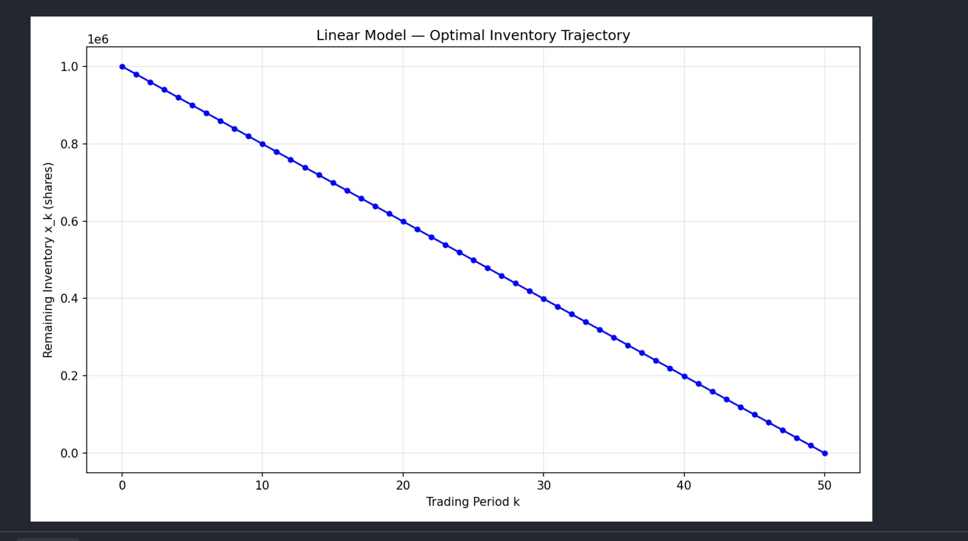
Figure 1. Optimal inventory trajectory under the linear Almgren-Chriss model with β = 1.0. The curve is nearly a straight line because the professor's risk aversion parameter γ = 2.5 × 10⁻⁶ is very small.
The total execution cost for this trajectory, measured under the linear model, is about $4.0 million. But this number is not directly meaningful on its own. It depends entirely on the specific cost function we used. What matters is how this cost compares to the cost of a trajectory computed under the more realistic power-law model.

4.2 Risk aversion and urgency
Before moving to the comparison, it helps to see how the linear model behaves under different levels of risk aversion. When γ is very small, the trader is patient and sells evenly. When γ is very large, the trader is panicked and dumps most shares at the start. The panel below shows three regimes of behavior:
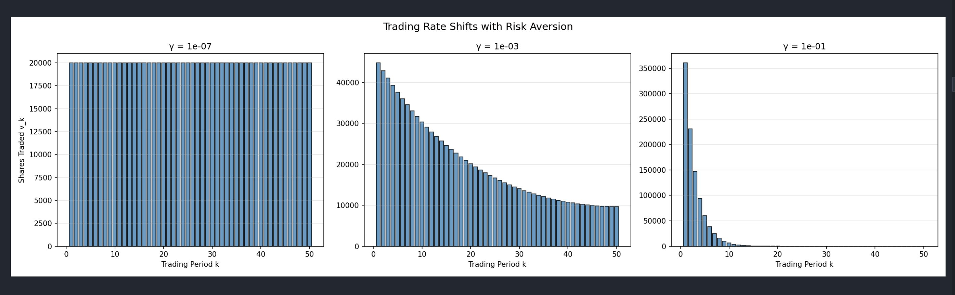
Figure 2. Trading rate shifts with risk aversion. Left: low γ gives uniform TWAP. Middle: moderate γ produces gentle front-loading. Right: high γ causes aggressive early selling.
This tells us that γ is the "dial" that sets the manager's urgency. The professor's baseline value of 2.5 × 10⁻⁶ sits at the patient end of the spectrum, which is why our main trajectory looks almost straight.

4.3 The power-law trajectory
When we set β = 0.6 and solve the power-law problem numerically, the result looks visually similar to the linear trajectory at the baseline parameters. The difference is there but hard to see with the naked eye.
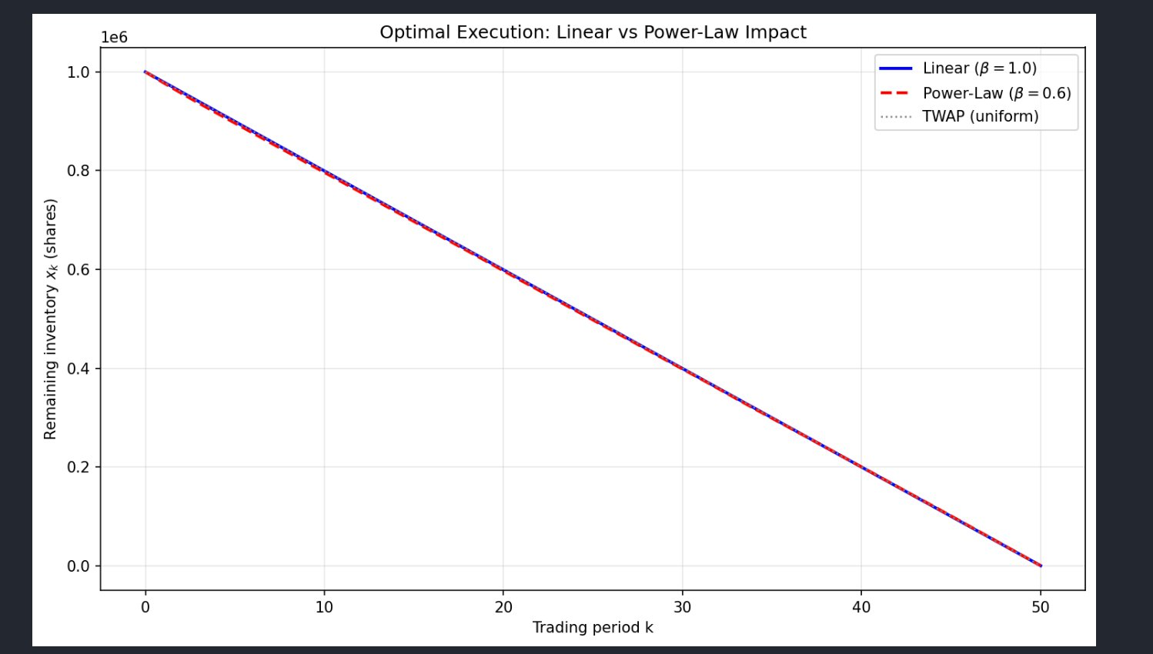
Figure 3. Linear trajectory (blue) vs power-law trajectory (red dashed) at professor's parameters. The two curves are nearly on top of each other, because γ is low. The small difference is where the cost gap comes from.

4.4 Cost mismatch analysis
This is the key result of the project. We ask a simple but important question: if the real market follows the power-law rule (β = 0.6), how much money do we lose by using the linear trajectory instead of the power-law trajectory?
To answer this, we compute four different costs:
Trajectory | Cost Model | Total Cost | Meaning
Linear | Linear (v²) | $4,016,156 | Manager thinks this is the cost
Linear | Power-law (|v|^1.6) | $92,289 | True cost of the naive strategy
Power-law | Power-law (|v|^1.6) | $92,197 | Lowest possible true cost
Power-law | Linear (v²) | $4,017,450 | Naive cost of the correct strategy

The first and last rows show costs measured under the linear model. These numbers look huge because the linear model overestimates impact. The second and third rows show the "real" costs when we apply the power-law cost function to both trajectories.
The difference between the second and third rows is the money left on the table:
Cost gap at baseline (β = 0.6)
$92,289 (naive linear strategy) − $92,197 (optimal power-law strategy)
= $92 ≈ 0.10% over the optimum.
At the baseline parameters, the gap is only $92. That is a tiny amount. In fact, the linear model is a reasonable approximation at β = 0.6 combined with very low γ. But this is only the beginning of the story.

4.5 The gap grows when the market is more non-linear
If we repeat the experiment at lower values of β, the results become dramatic. We run the same comparison for β = 0.3, 0.4, 0.5, 0.6, …, 1.0. Each time we compute the linear trajectory, apply the power-law cost function, and measure the gap against the power-law optimum.
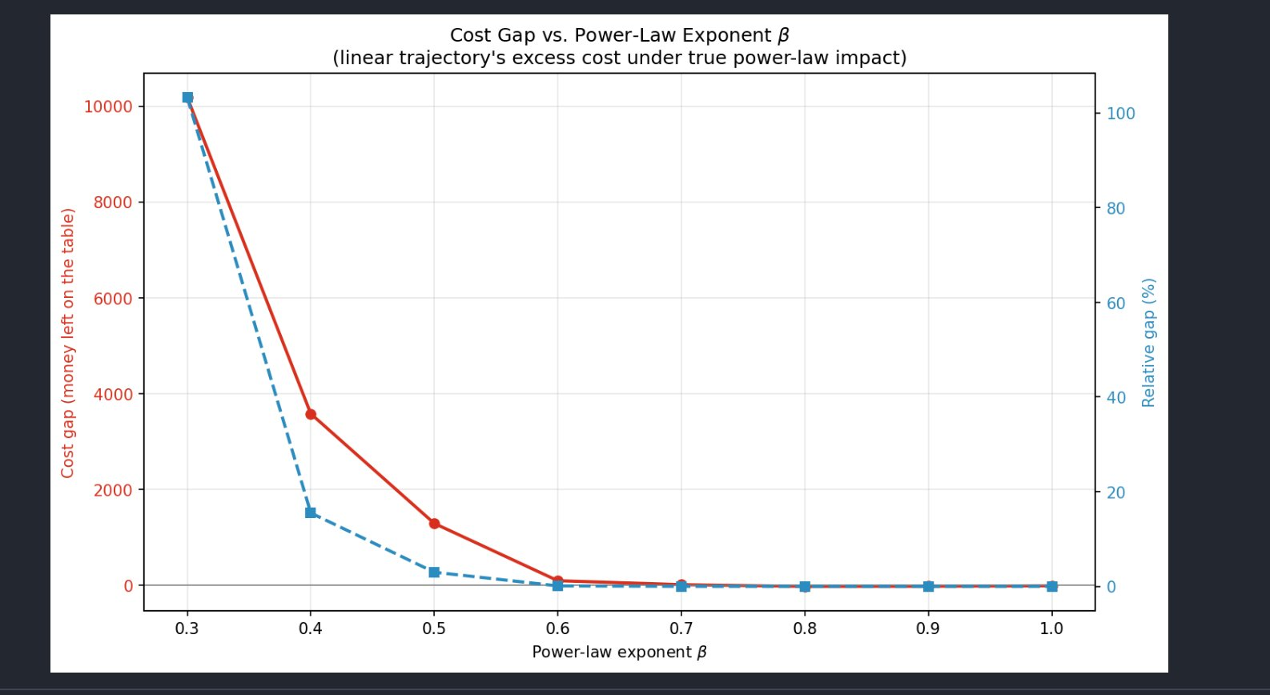
Figure 4. Cost gap as a function of the impact exponent β. The solid red line is the dollar gap. The dashed blue line is the relative gap (percentage over optimum). Both axes use the same β values.
At β = 0.6, the gap is only 0.1%. But at β = 0.5, it jumps to 3%. At β = 0.4, it becomes 15.5%. And at β = 0.3, the gap reaches 103%, meaning the linear strategy costs double what an optimal power-law strategy would cost.
The intuition is simple. When the market is highly non-linear, large trades cost less than the linear model predicts. A smart trader should take advantage of this and front-load the schedule. But the linear model does not know the market is non-linear. It is stuck believing that big trades are always expensive, so it spreads the trades out evenly. That over-cautious behavior is exactly what wastes money as β decreases.

4.6 Risk aversion amplifies the gap
The second finding is that the gap also grows when risk aversion γ increases. At low γ, the two models agree. At moderate γ, their trajectories begin to diverge. At high γ, the difference becomes large and clearly visible.
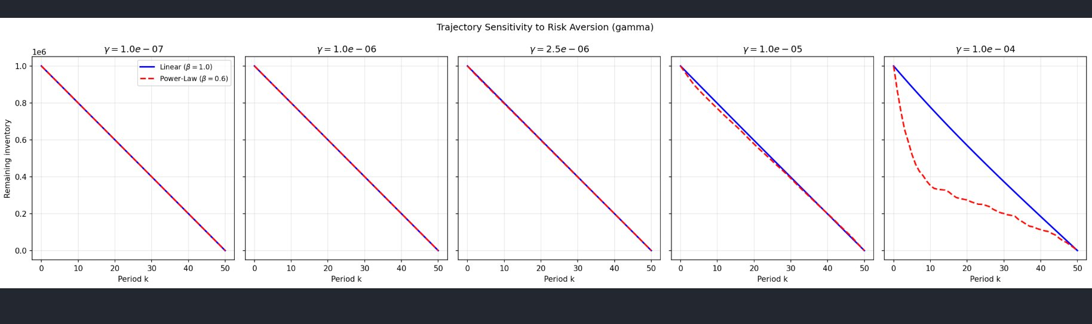
Figure 5. Trajectory sensitivity to γ, comparing linear and power-law models. At low γ (left panels) the curves overlap. At high γ (right panels) they diverge sharply — the power-law model front-loads much more aggressively than the linear model.

5. Discussion and Conclusion
Our results have two main messages for a reader interested in execution strategy.

5.1 When does the linear model work?
The linear Almgren-Chriss model works well when two conditions hold. First, the market impact must be close to quadratic, meaning β must be near 1.0. Second, the risk aversion γ must be low, meaning the liquidation is not urgent. In these cases, the extra cost of using the linear model instead of the true power-law model is under 1%.
At the baseline parameters given by the professor (β = 0.6 and γ = 2.5 × 10⁻⁶), the approximation error is only 0.1%. For practical purposes, this is negligible.

5.2 When does the linear model fail?
The linear model breaks down in two scenarios. First, when the market is strongly non-linear (β ≤ 0.4), the gap explodes into the double digits. In the most extreme case we tested, at β = 0.3, the linear strategy costs double the optimum. Second, when risk aversion is high and liquidation is urgent, the two models diverge sharply even at the professor's β = 0.6.
In the real world, execution desks rarely know the exact value of β in advance. They must estimate it empirically from historical trade data. Our results show that using a linear approximation is risky: small errors in the true β can lead to very large errors in execution cost.

5.3 Takeaway
The practical lesson is simple. Execution algorithms should use calibrated, empirical impact models rather than assume linearity. The mathematical elegance of the classical Almgren-Chriss closed form is attractive, but the gain from using a more realistic model can be significant. Our project demonstrates that this is especially true for illiquid stocks (low β) and urgent liquidations (high γ).

5.4 Limitations and future work
Our implementation has a few limitations. The SLSQP solver sometimes struggles to converge when β is very small, which leads to slight jaggedness in the most extreme trajectories. A more robust solver, such as CVXPY with power-cone constraints, would handle these cases better.
Future extensions could include: (i) cross-impact between multiple correlated assets, (ii) stochastic volatility instead of constant σ, (iii) adaptive execution that updates the schedule in real time as new price information arrives, and (iv) empirical calibration of β from real market data.

6. References
[1] Almgren, R. and Chriss, N. (2000). Optimal execution of portfolio transactions. Journal of Risk, 3(2), 5–39.
[2] Almgren, R., Thum, C., Hauptmann, E., and Li, H. (2005). Direct estimation of equity market impact. Risk, 18(7), 58–62.
[3] Bouchaud, J.-P. (2010). Price impact. In Encyclopedia of Quantitative Finance.
[4] Cornuéjols, G. and Tütüncü, R. (2007). Optimization Methods in Finance. Cambridge University Press. (Course textbook.)

